Week 10: Angular and .NET

Worked on the patient demographics module. Developed a patient’s page with filters.

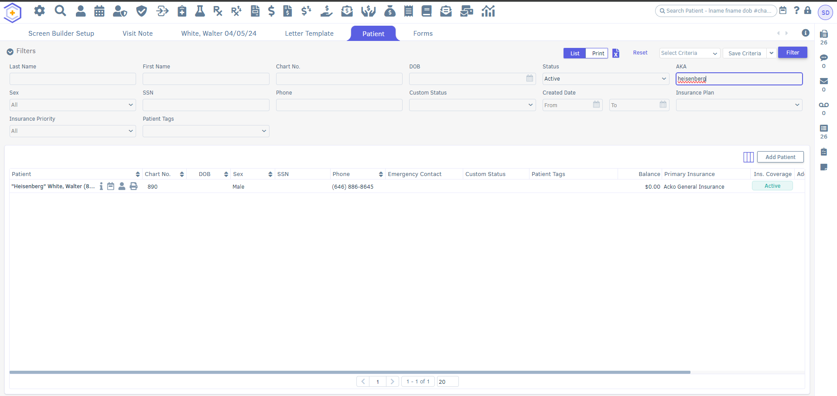

Week 11: CRUD and filters in postgres & Dbeaver.

Using Dbeaver and Postgres, implemented patient’s filters in demographics.

Started developing Forms for the Appointments. Developed Actions and Filters alongside it.

Also prepared release notes for QF2.1 release.

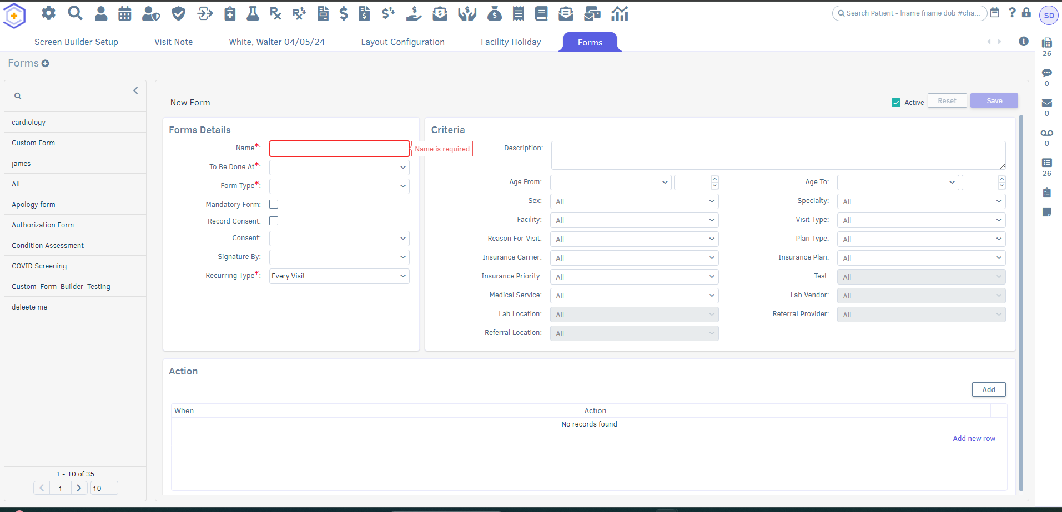

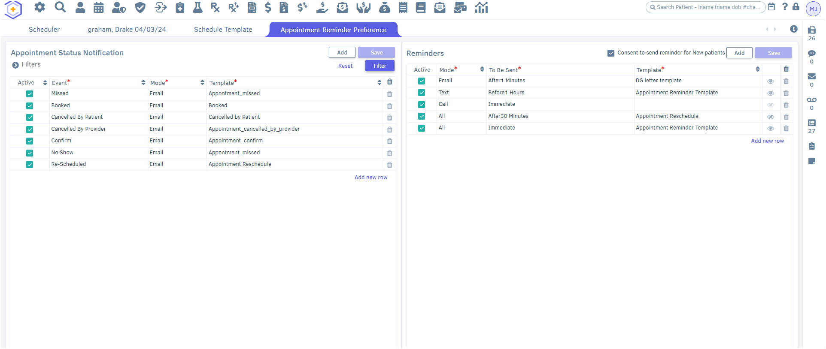

Week 12:

Started exploring Forms And Consent modules. Tested that module, reported found bugs and discussed it with developers. Prepared user scenarios and test cases for documentation.

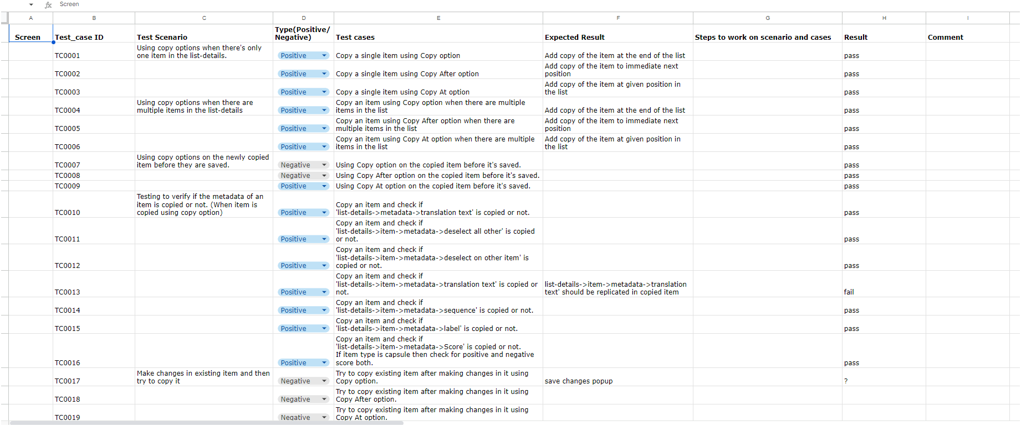

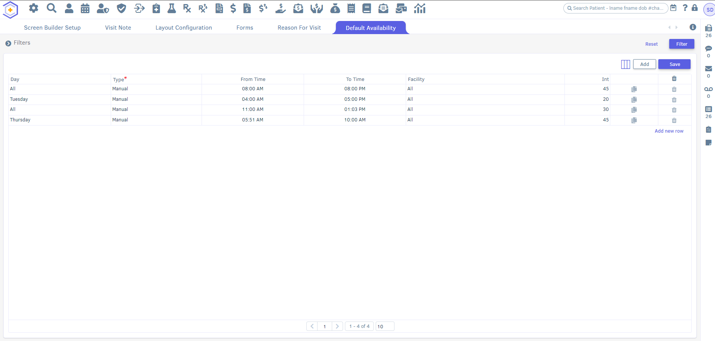

Week 13: Started developing Dr. Catalyst Consents and Default Availability.

Also solved the assigned bugs for the Custom Form Builder module. Solved ER and reported it to the Quality Analyst lead.

